**PROJECT REPORT TEMPLATE**

**1 INTRODUCTION**

**Overview**

**Designing a infographic using canva**

**An infographic is a visual representation of information.rather than having blocks and blocks of text that people will never read,you give them the same information is a different way and is one they will easily understand.**

**2 PROBLEM DEFINITION & DESIGN THINKING**

**Empathy map**

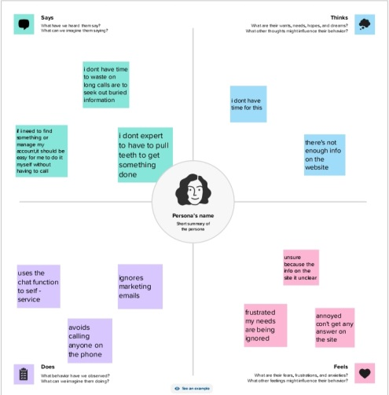

Ideation and brainstorming map

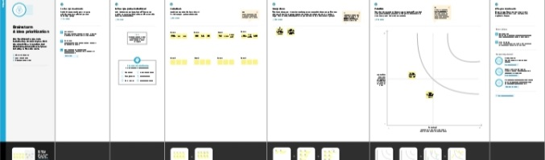

Result



4 ADVANTAGES AND DISADVANTAGES

Templates can be altered to be more custome .canva offers a professional look.

Limitation of number of templates.alingment concerns.

APPLICATIONS

Canva makes designing beautiful creative assets easy for everyone .

CONCLUSION

We learn a lot of new things about editing in canva.I have also learnt how to make a infographic in canva